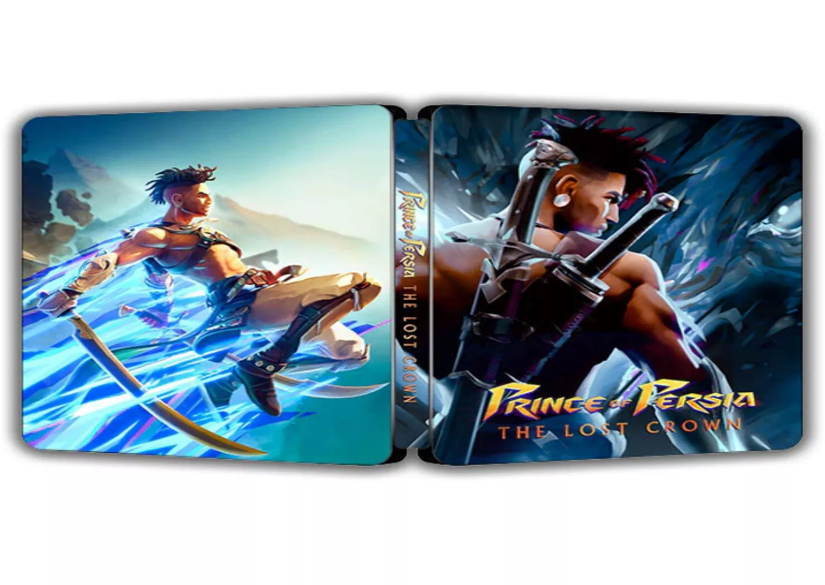

*Prince of Persia: The Lost Crown:*

1️. **Metroidvania-Style Exploration**

* The game a **2.5D side-scrolling Metroidvania format**, allowing **unlock new areas** .
* Features **intricate level design**, requiring backtracking and skillful platforming.

2️. **Fast-Paced Combat & Time Powers**

* Players control **Sargon**, **agile melee combat** and **time-manipulation abilities**.
* Battles **combo attacks, dodging, and parries**, with challenging **boss fights**.

3️. **Mythological Persian Setting**

* The game takes place in **Mount Qaf**, a mystical land inspired by **Persian mythology**.
* Players embark on a quest to **rescue Prince Ghassan** and uncover ancient secrets.

4️. **Stunning Visuals & Smooth Animation**

* Uses a **stylized art design** with **fluid animations**, and movement visually striking.
* The environments are rich with **colorful Persian-inspired architecture**.

5️. **Post-Launch DLC & Accessibility Features**

* **Mask of Darkness DLC** expands the story with new content.